* 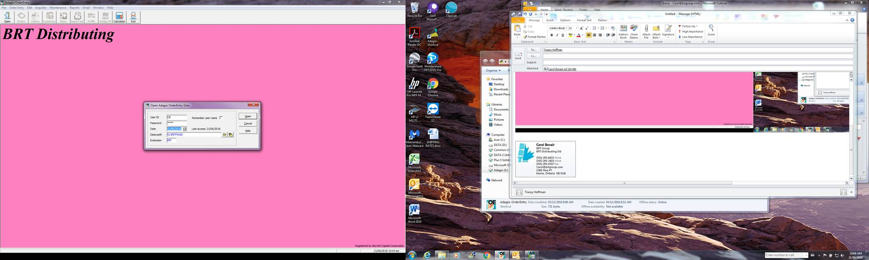 **Select BRT Distributing (Pet Foods)**

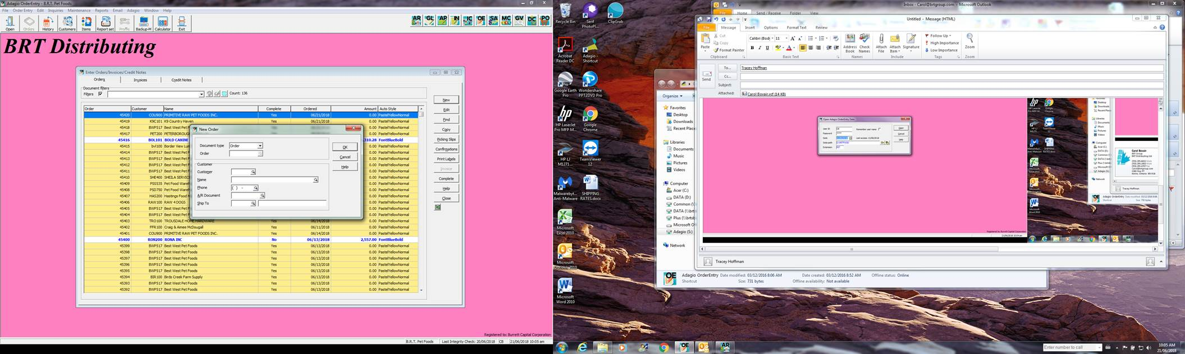From Orders Tab **select new**

In customer field f6 to find new customer.

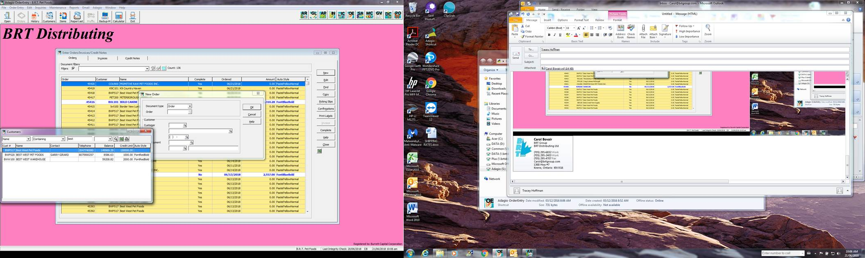

**Change search to by name**

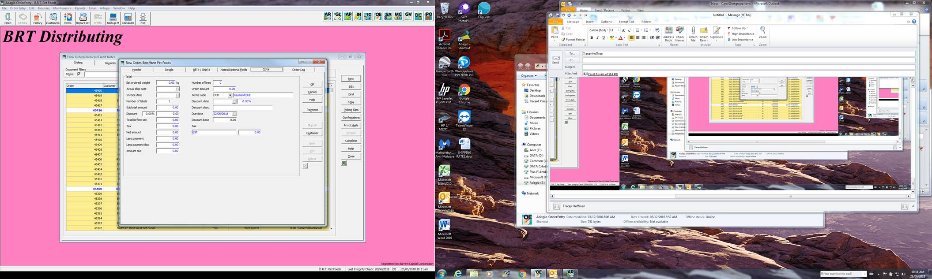

**Header Tab**

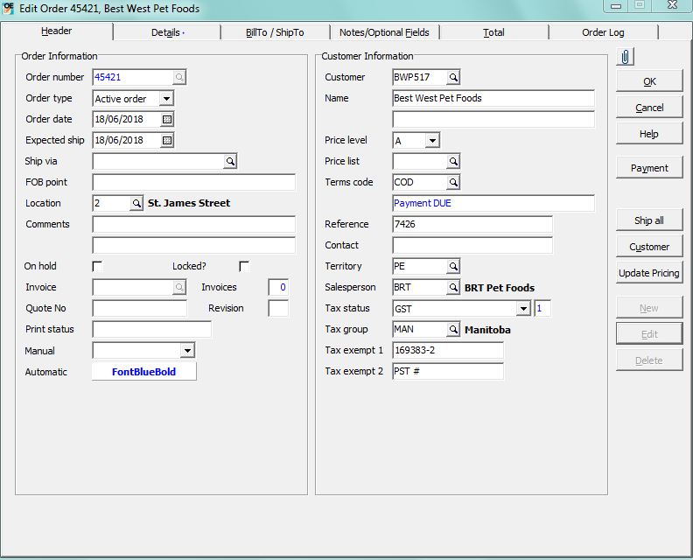

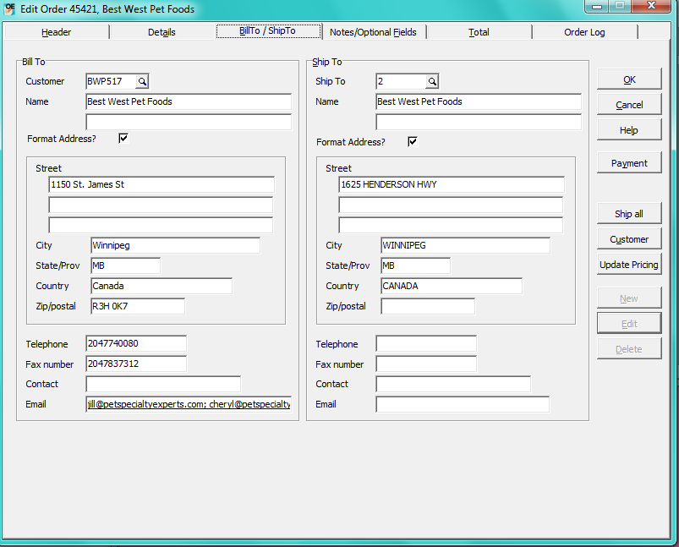

**Adding Products**

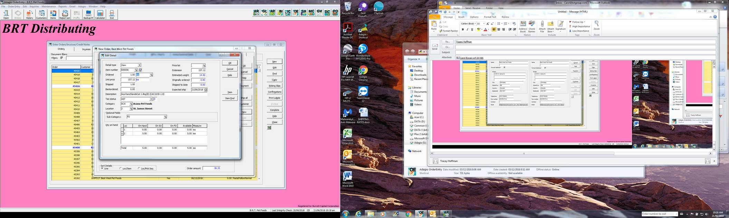

**Item # is ALT PLU on pick sheet.**

**Ordered should always match shipped #**

**Change from invoice to order until you are ready to invoice.**

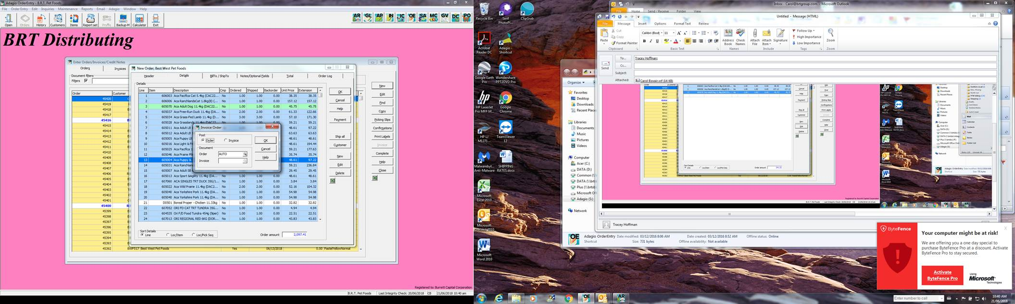

**Invoicing**

If going directly to invoicing, make sure invoice is selected and then hit OK.



If coming back to invoicing later, find your orders in the Order Tab, verify your info and hit OK, make sure invoice is selected and hit OK again.

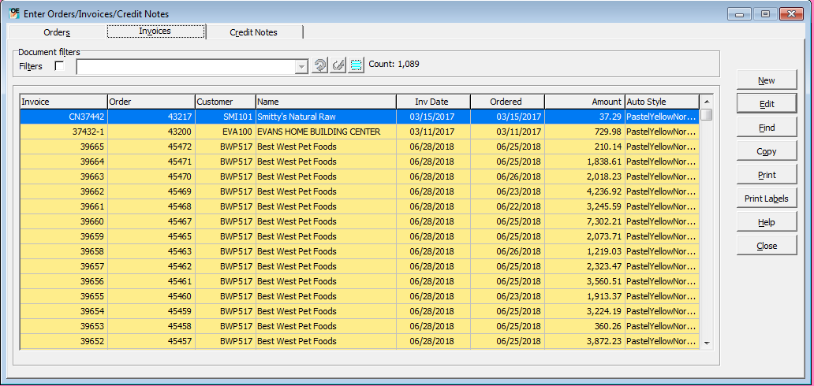

Find your invoice, select print.

Either Print as a PDF or as a regular invoice.

